**World Population Data Analytics using IBM Cognos**

**A PROJECT REPORT**

**Submitted by**

**RACHITA JHA**

**19BCE10283**

in partial fulfilment for the award of the degree

of

**BACHELOR OF TECHNOLOGY**

in

**PROGRAM OF STUDY**



SCHOOL OF COMPUTING SCIENCE AND ENGINEERING

**VIT BHOPAL UNIVERSITY**

**KOTHRIKALAN, SEHORE**

**MADHYA PRADESH – 466114**

MAY 2022

**LIST OF FIGURES**

|  |  |  |
| --- | --- | --- |
| Fig No. | Title | Page No. |
| 1 | IBM Cognos Analytics Architecture | 4 |
| 2 | Flowchart | 5 |
| 3 | IBM Cloud Creation | 6 |
| 4 | IBM Cognos Analytics | 6 |
| 5 | Understand the dataset | 7 |
| 6 | Loading the dataset | 7 |
| 7 | Prepare the datasets | 8 |
| 8 | Top10 Pop Total by Location Using Tree Map | 8 |
| 9 | Pop Total by Time Using Line Chart | 9 |
| 10 | Pop Male by Location and Pop Female by Location using Pie Charts | 9 |
| 11 | Pop Male by Time and Pop Female Using Packed Bubble Charts | 10-11 |
| 12  13 | Building of Dashboard    Pop Male, Pop Female and Pop Total using Summary | 11    12 |

**TABLE OF CONTENTS**

|  |  |  |
| --- | --- | --- |
|  | TITLE | PAGE NO. |
| 1 | INTRODUCTION                   1.1 Overview | 4 |
| 2 | THEORETICAL ANALYSIS                    3.1 Block Diagram | 6 |
| 3 | FLOWCHART | 7 |
| 4 | PROCESS |  |
| 5 | RESULT | 8-12 |
| 6 | ADVANTAGES AND DISADVANTAGES | 13 |
| 7 | APPLICATIONS | 14 |
| 8 | CONCLUSION | 15 |

**1. INTRODUCTION**

**1.1 Overview**

This interactive data query offers data for selected indicators from the medium variant of World Population Prospects 2019. A set of Excel files containing all available indicators and other projection variants (see Definition of Projection Variants for further details), including probabilistic results, is available from the Download Center. For advanced users who need to use these data in a database form or statistical software, we recommend to use the CSV format for bulk download.

On 28 August 2019 a minor technical correction was made to the population projected after 2050 for selected countries and regions, and to the population interpolated by single year and single age for both sexes, see release note for further details. Interactive Data, Excel and CSV files have been updated accordingly.

**2. THEORETICALANALYSIS**

2.1 BLOCK DIAGRAM

IBM Cognos Analytics Architecture (High Level)

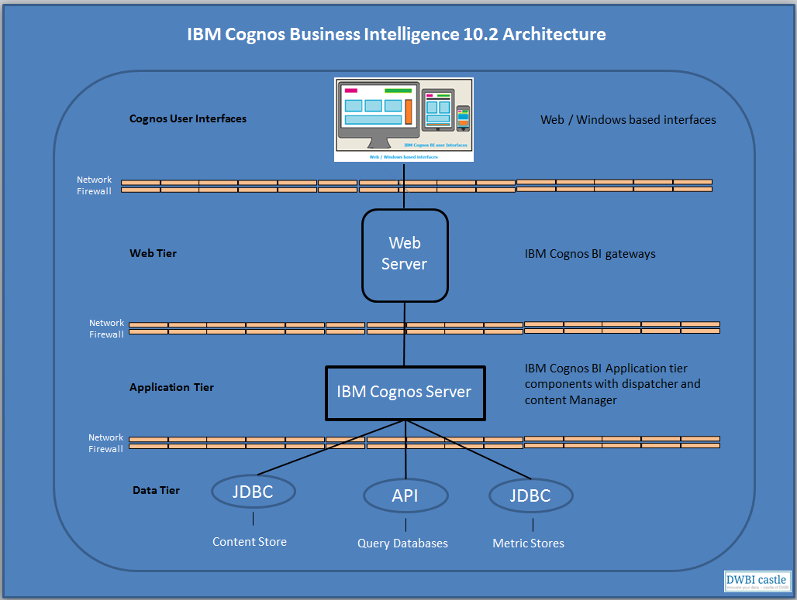

**3. FLOWCHART**

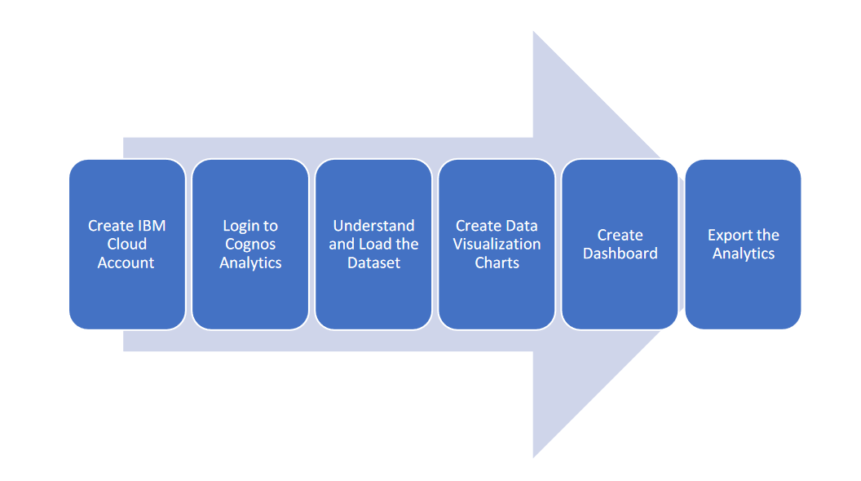

**4. PROCESS**

4.1 IBM Cloud Creation

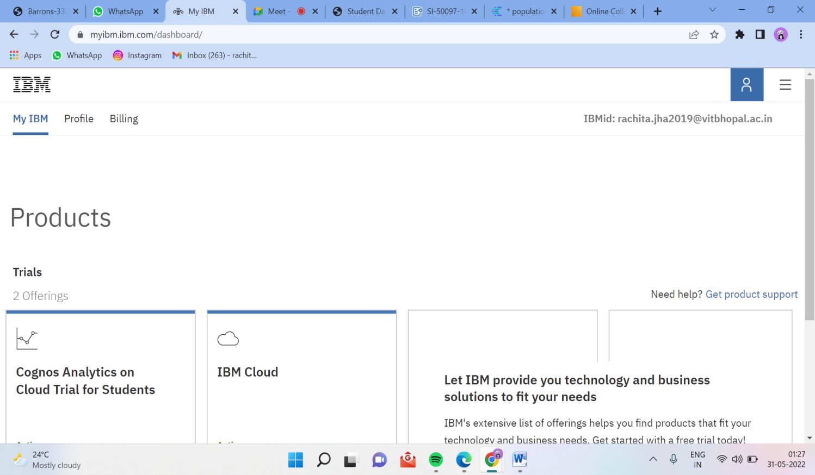

4.2 IBM Cognos Analytics

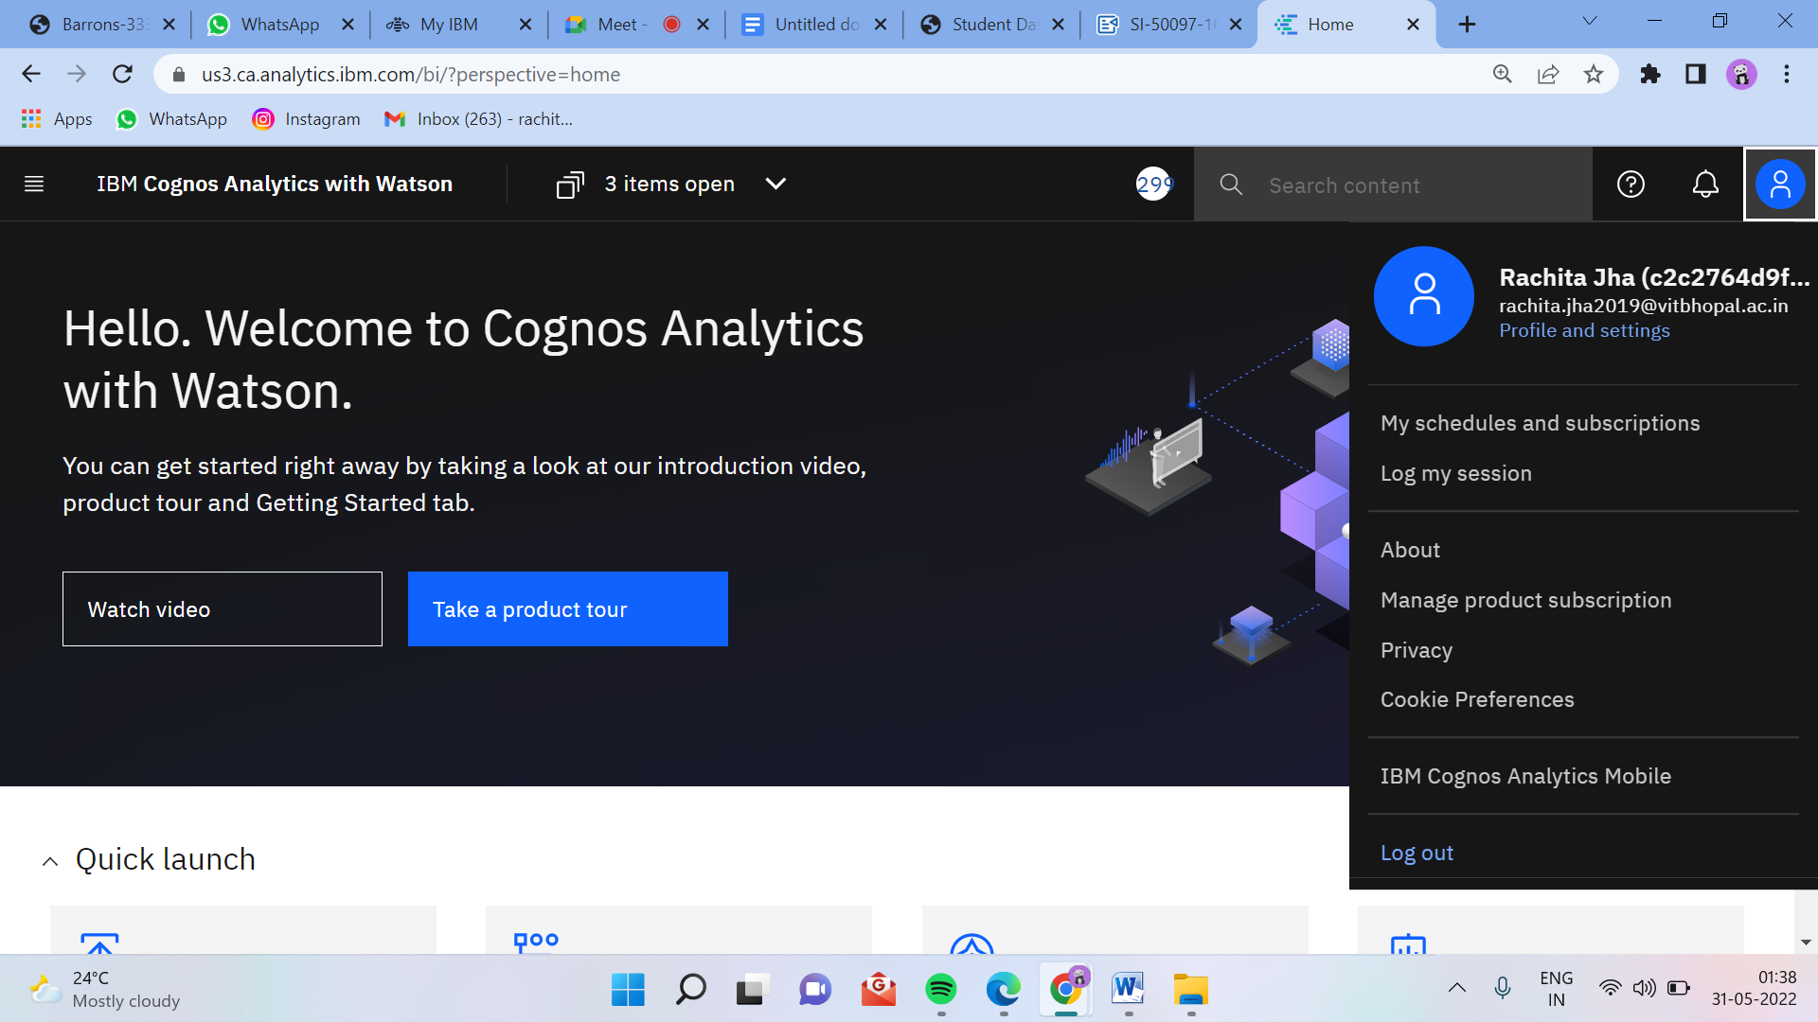

4.3 Working with the dataset

4.3.1 Understand the dataset

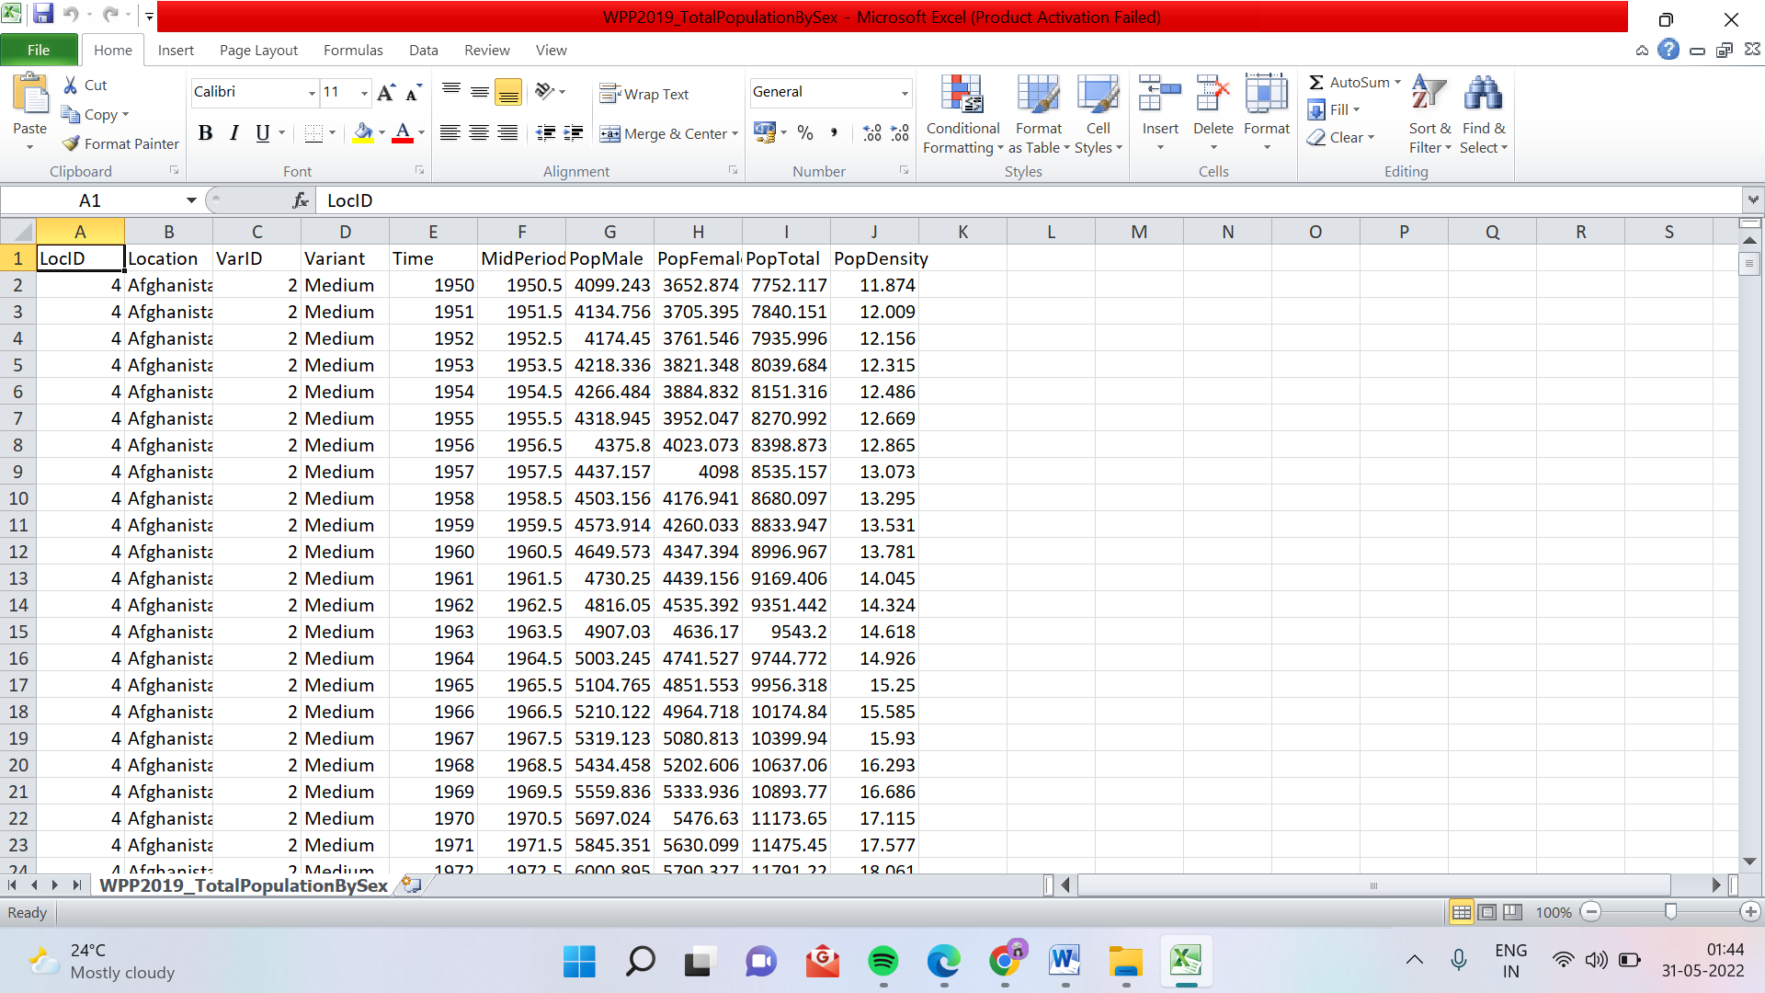

4.3.2 Loading the dataset

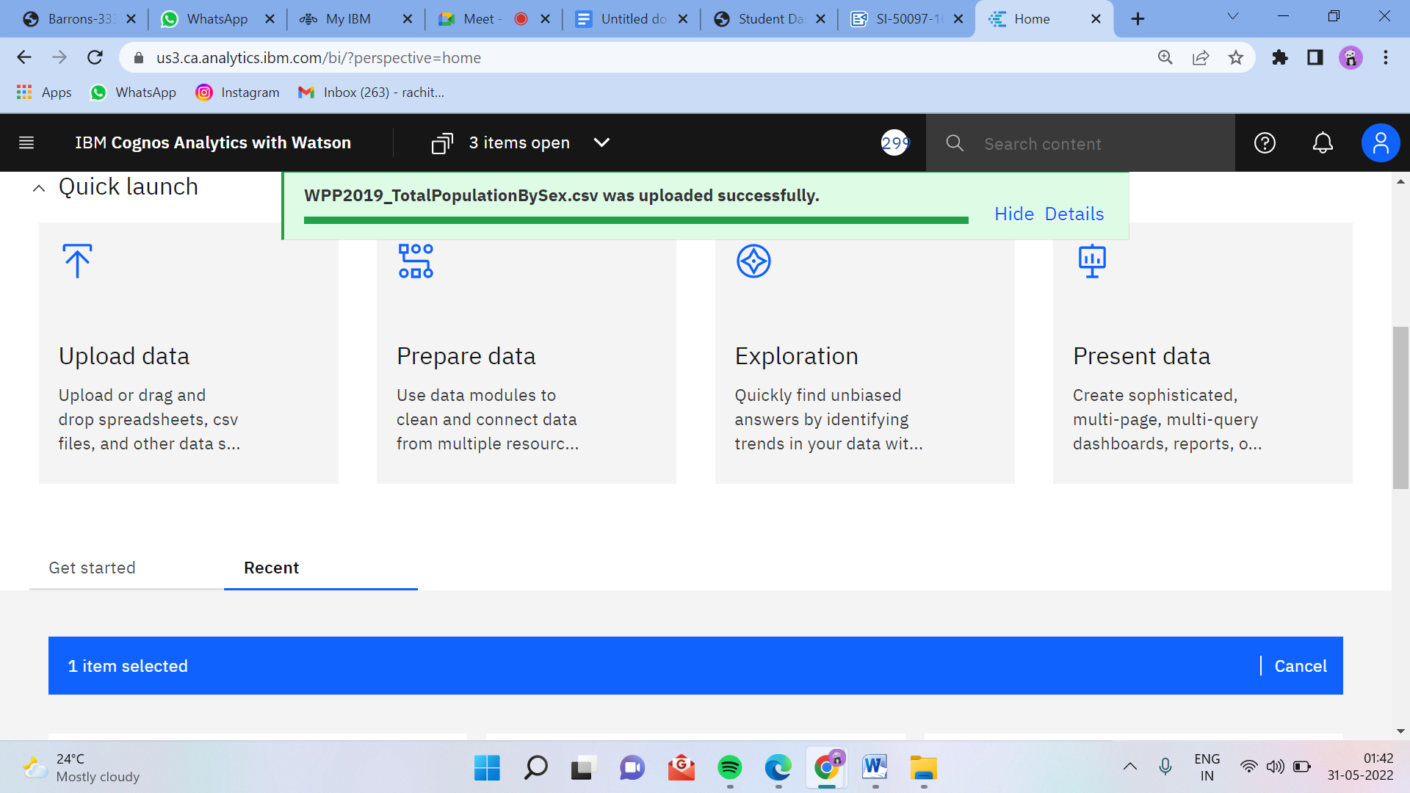

4. 3.3 Prepare the datasets

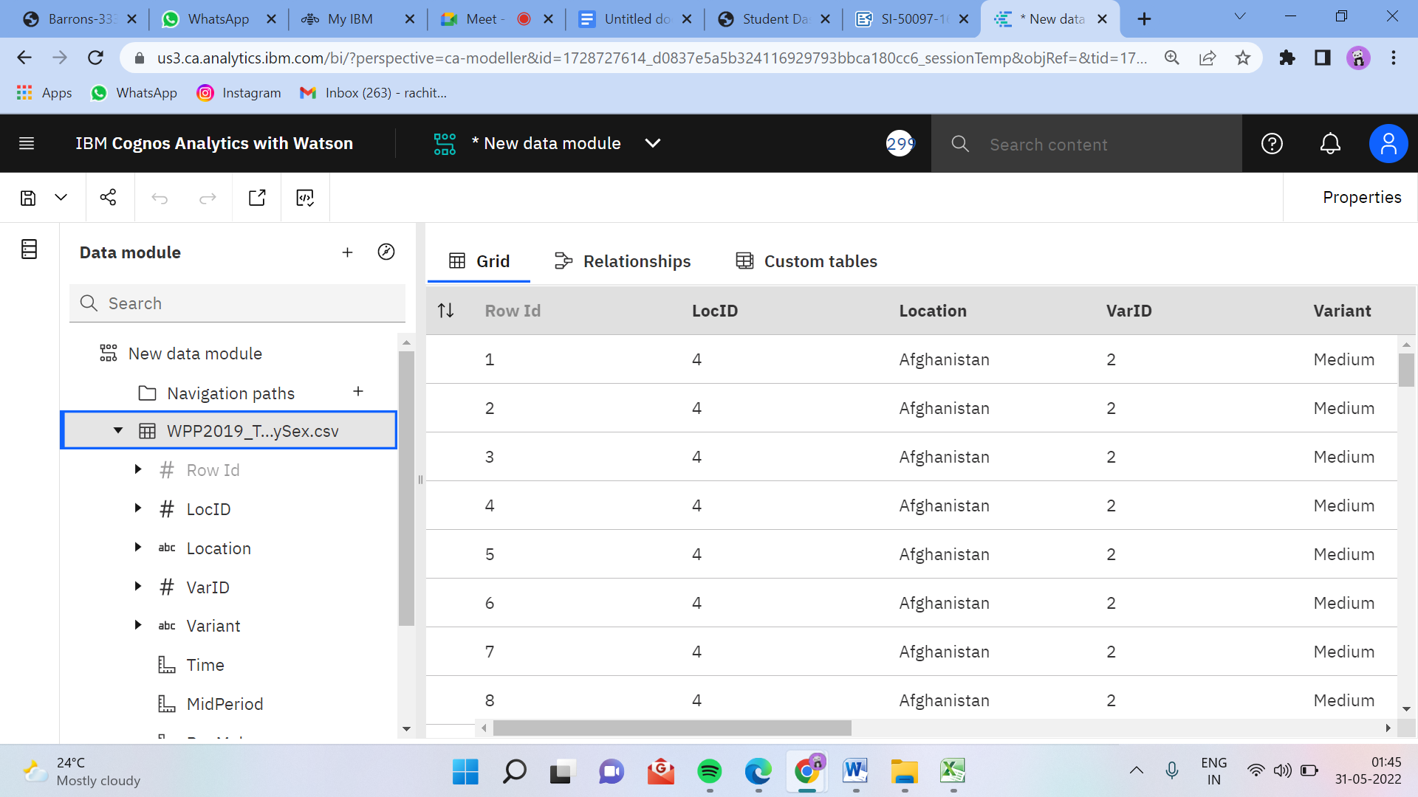

**5. RESULT**

**Data Visualization Chart**

5.1 Top10 Pop Total by Location Using Tree Map

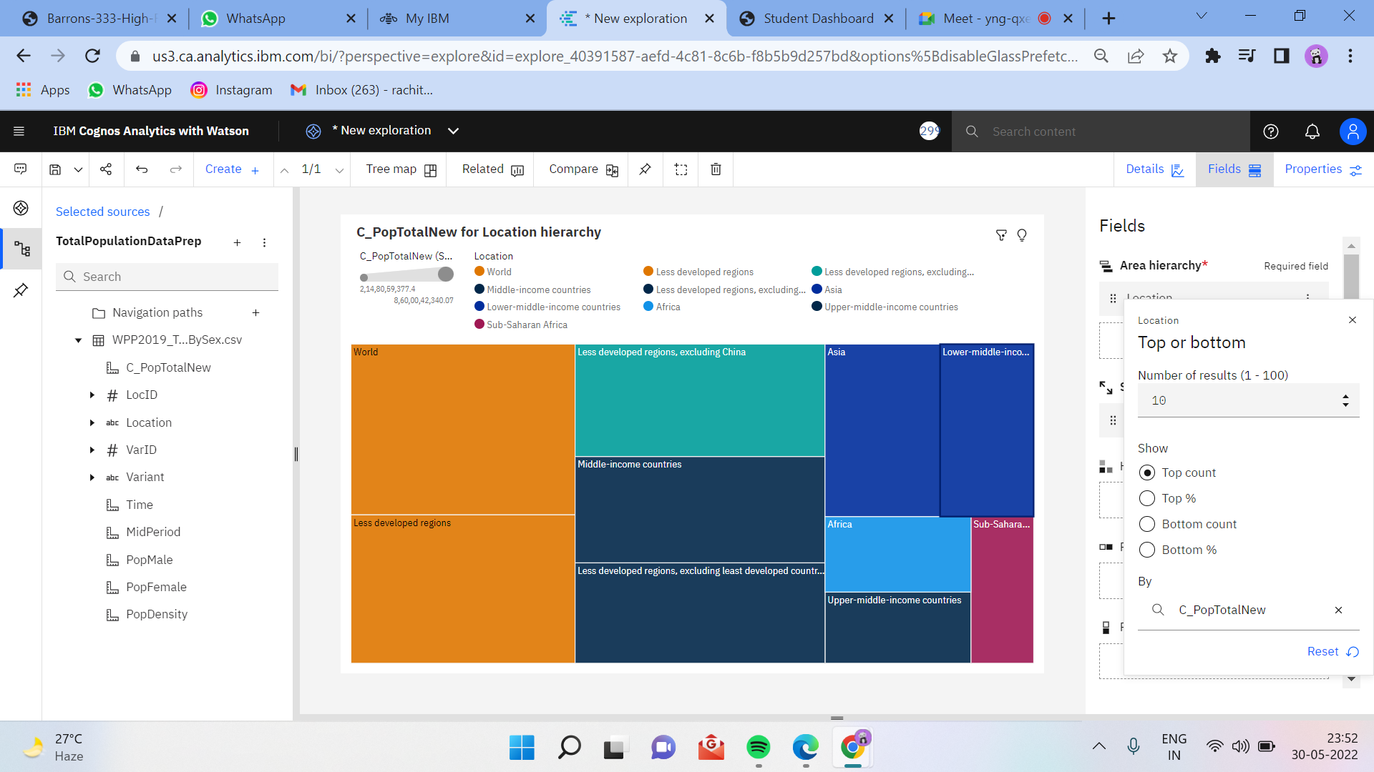

5.2 Pop Total by Time Using Line Chart

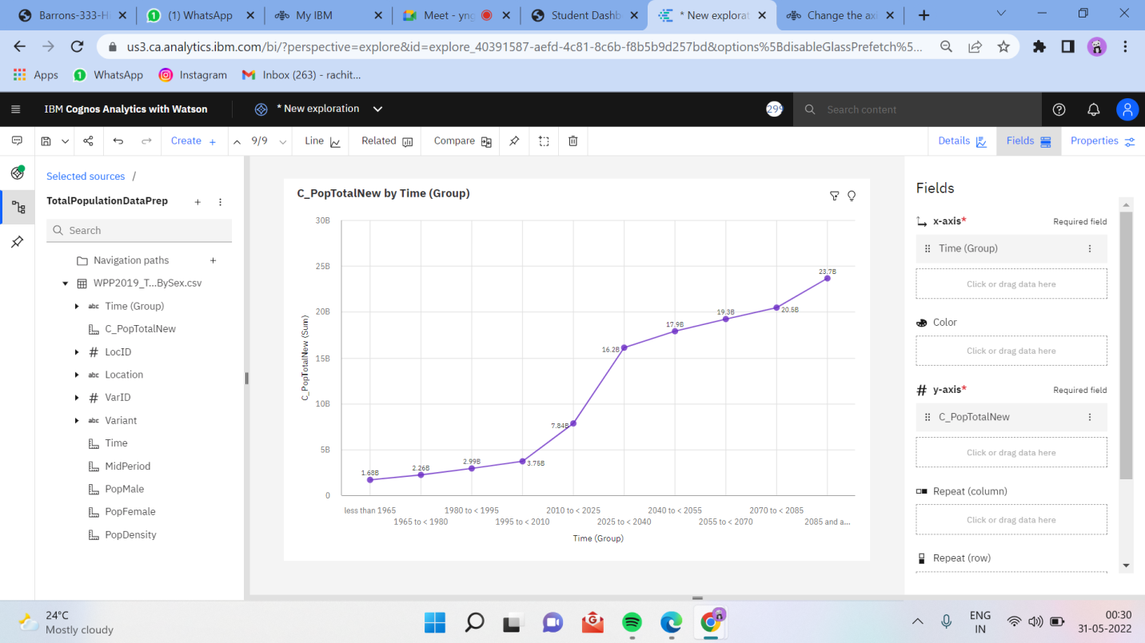

5.3 Pop Male by Location and Pop Female by Location using Pie Charts

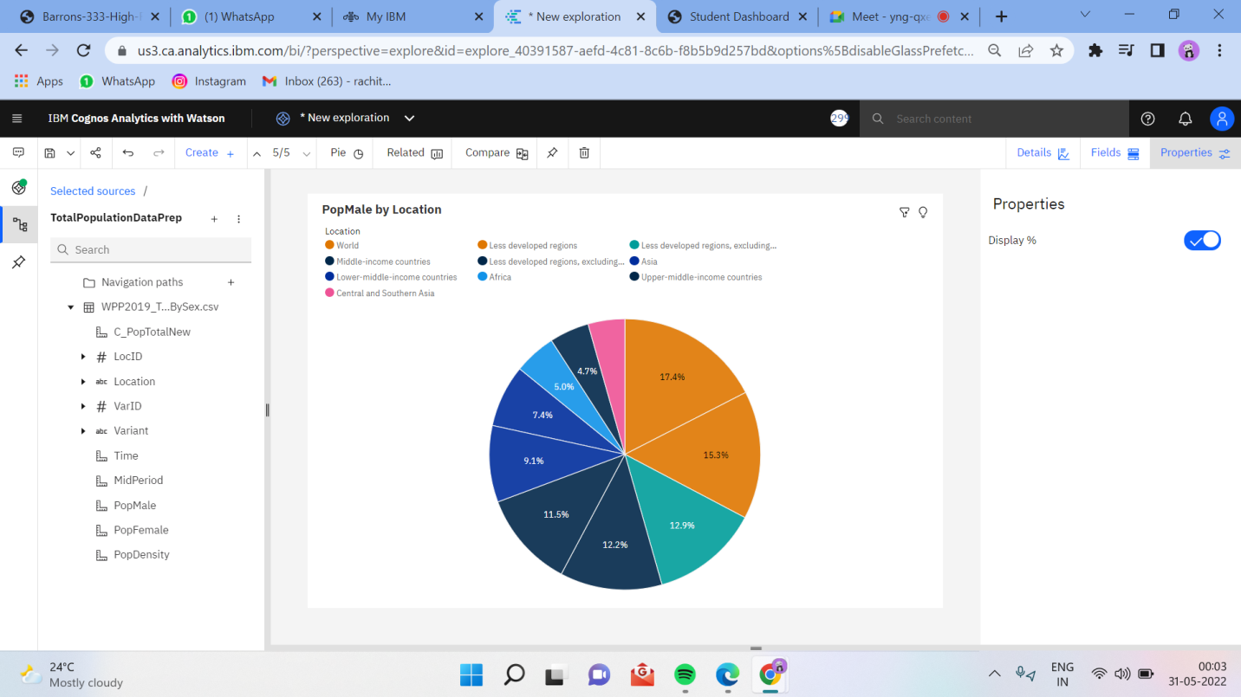

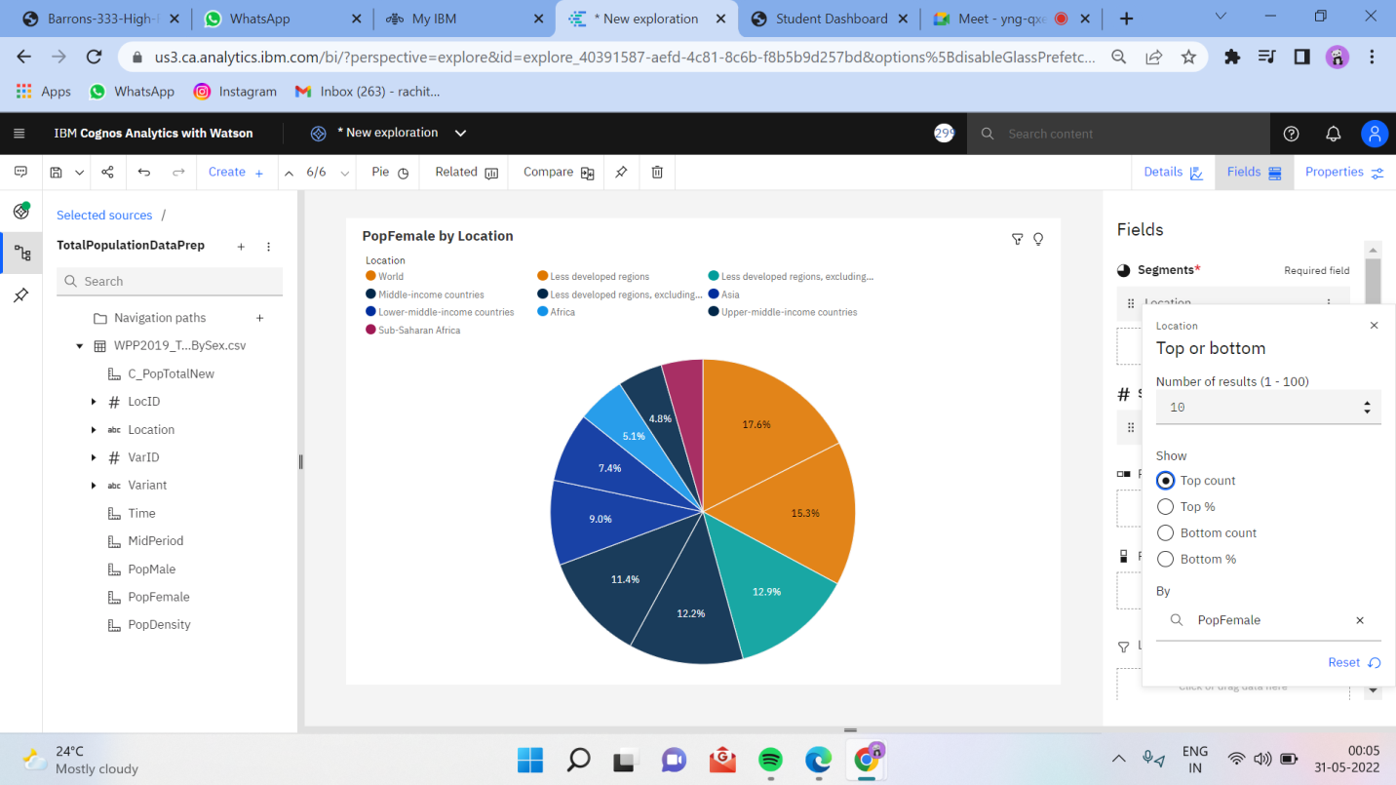

5.4 Pop Male by Time and Pop Female Using Packed Bubble Charts

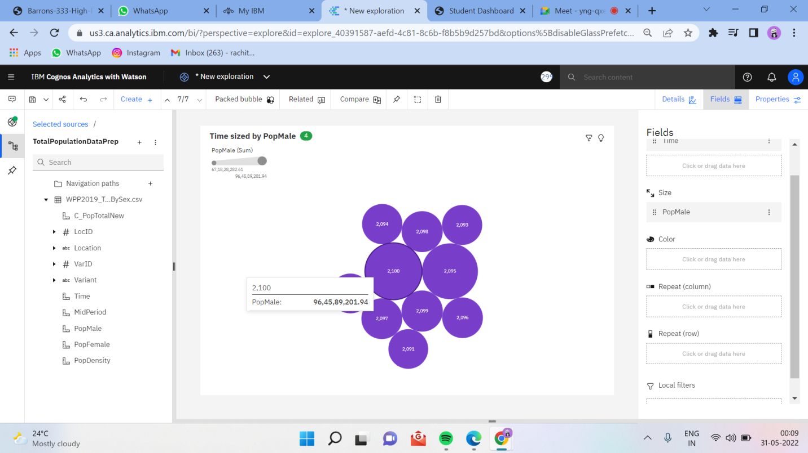

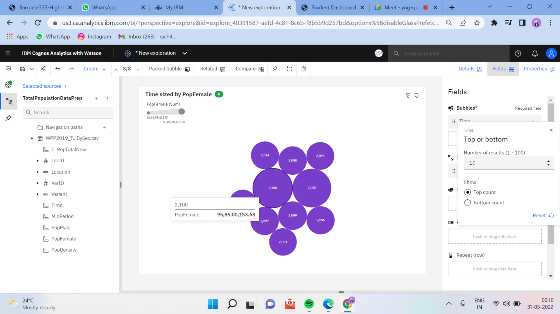

5.5 Building of Dashboard

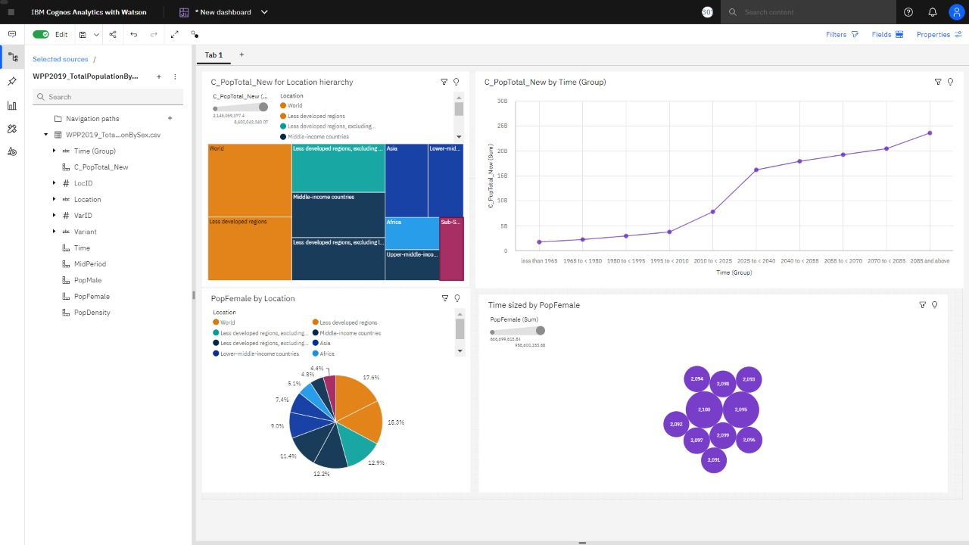

5.6 Pop Male, Pop Female and Pop Total using Summary

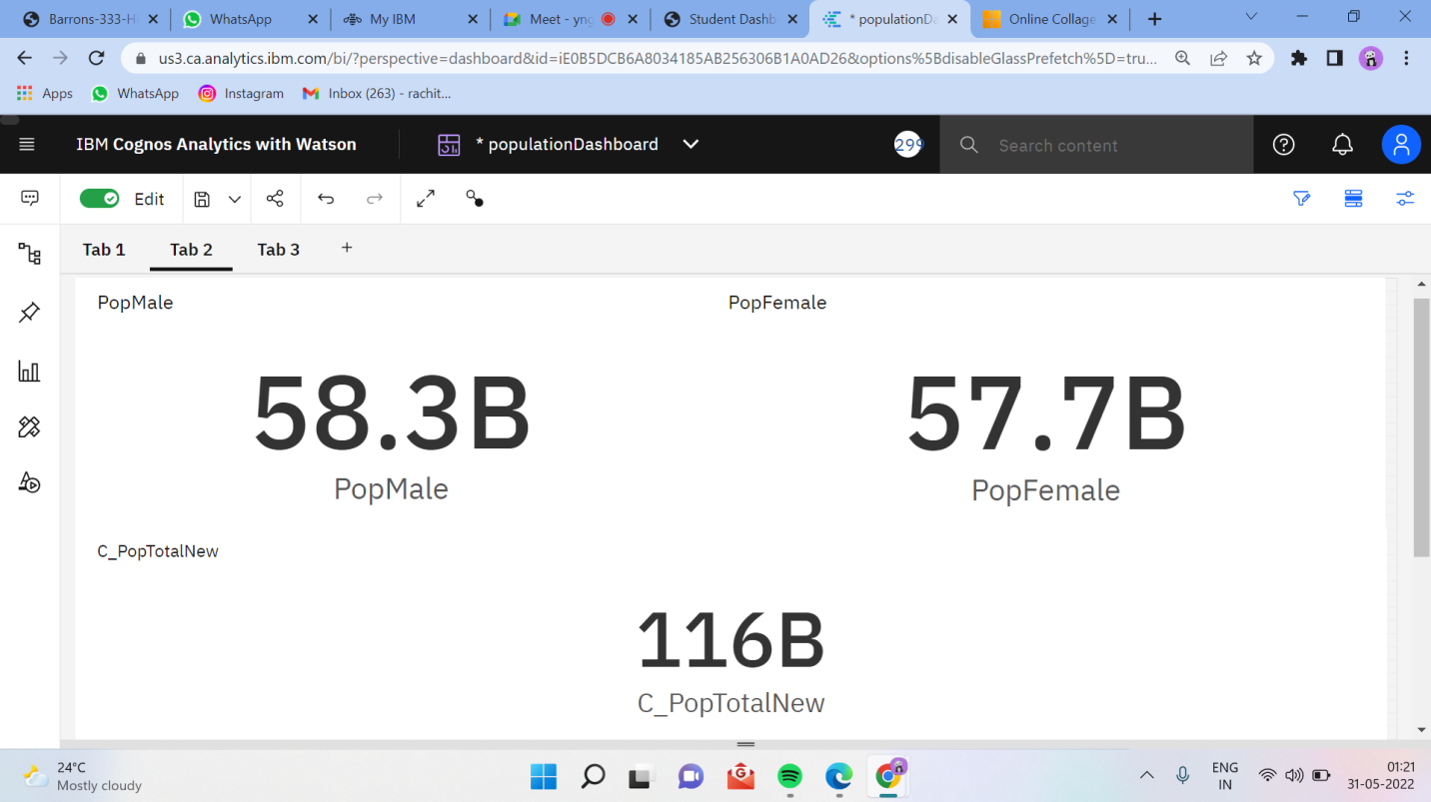

**6. ADVANTAGES AND DISADVANTAGES**

**Advantages of dashboard visualisation**

1. Visualized data is processed faster-   Visual content is processed much faster and easier than text. Data visualization taps into this concept of how quickly our brains can recognize images and make sense of them.

2. Data visualization dashboards support visual learners-   While [90% of information](https://www.studyingstyle.com/visual-learners) submitted to the brain is visual, learning styles vary among the population. Some learn kinesthetically, while others are auditory learners. The majority of the population however, [65% to be exact](https://www.studyingstyle.com/visual-learners), are visual learners. Data visualization and online data visualization tools help make it possible to quickly comprehend the information presented. Moving past the spreadsheet era, modern technology has transformed information from generic spreadsheets into appealing and easy-to-read charts and graphs. Online data visualization is a tool to present data visually and gain insights from that data.

3. Data visualization tools show insights, causes, and trends that may be missed in traditional reports.

4. Data visualization gives actionable items-   Data visualization may help your organization see where there’s room for improvement or where performance is high. Actionable items can result by identifying successes and areas for improvement.

5. Data visualization increases productivity and sales-   Being able to visualize data produces real results. The time saved in creating up-to-date reports means greater efficiency companywide.

**Disadvantages of dashboard visualisation**

1. Dashboards are a popular tool for data visualization, but they have some distinct disadvantages.

2. Dashboards can be overwhelming, particularly if they try to pack in too much information. It can be difficult for users to know where to look and what is most important.

3. Dashboards are often static, meaning that they don’t update in real-time as data changes. This can make them less useful for tracking fast-moving trends.

4. Dashboards can get difficult to customize, meaning that users may not be able to tailor them to their specific needs. For these reasons, dashboards should be used carefully and only when they offer the best way to visualize the desired data.

5. Dashboards can also be misleading if they are not used correctly. It is easy to cherry-pick data (data bias) that supports a particular argument while ignoring data that does not. This is also called confirmation bias. As a result, dashboards should be used carefully and only as one part of a broader analytical approach.

**7. APPLICATIONS**

1. If you manage complex campaigns, you usually end up having several analytics solutions for each platform and needing to consult them separately, which hinders the overall view. Instead, the dashboard displays data from different sources, like web analytics solutions, social media metrics. This way, makes it much easier to compare them and see how they develop.

2. A good dashboard clearly shows you a number of key metrics so you don't need to be an analytics expert to understand them. If you want to look further into a particular data set, you always have the option of employing more specific tools.

3. If you synchronize your dashboard automatically in the cloud, you can create different users so that your entire team can access the same information from anywhere. It's even possible to project the dashboard onto a screen in your office so that the whole team can see what is going on in real time.

4. Having a centralized dashboard will save you a lot of time. Instead of collecting data from different sources and making charts on your own, dashboards do all this work for you. You just need to invest some time at the beginning to set up the metrics and decide how to present them. From that point on, the reports are created automatically.

**8. CONCLUSION**

It was a wonderful learning experience for me while working on this project and vizualising charts of World Population Analytics using IBM Cognos. This project took me through the various phases of project development and gave me real insight into the world of data analysis. The joy of working and the thrill involved while tackling the various problems and challenges gave me a feel of the analytics’ industry.

From this project, we have successfully:

1. Created multiple analysis charts / graph.

2. Used the analysed chart creation of dashboard

3. Saved and visualized the final dashboard in the IBM Cognos Analytics

It was due to this project I came to know how data analyst is designed.

Demo Link:

<https://drive.google.com/file/d/1r1x-1AaPNnAQ6WPCl5VUP9QL-8rptfr_/view?usp=sharing>